(Approx. 1544 words)

A Windows 10 screen saver to display your photos
Put your computer to work when you are not using it, to show off your favorite photos automatically
Author: John Krout, Member, Potomac Area Technology and Computer Society (PATACS)
www.patacs.org
jkrout75 (at) yahoo.com

You are swimming, or perhaps sinking, in an ocean of photos. Your relatives and friends send photos all the time. You might shoot some yourself too.

You can turn those photos into an entertaining and personalized slide show screen saver on your Windows computer. Read on to learn how.

WHAT IS A SCREEN SAVER?
Many years ago, before flat-screen monitors became available, we used TV-like cathode ray tube (CRT) computer monitors. Those were big and ungainly things, power-hungry, and I am glad they are gone. But they had another significant problem: if an image was displayed on the screen for a very long time, the phosphors on the screen became “burned” by the brightest portions of the image. Those burns were permanent, and those burned portions of the screen were unable to portray whatever the computer wanted to show there later.

Hence screen savers were born, simple programs that appeared automatically after some minutes of computer inactivity, displaying moving images so that no burns could happen. Several screen savers are provided by Windows 10 and prior versions of Windows.

That same burn effect could also happen to TV cameras of that era. One of the most famous occurred in the TV camera carried to the Moon by the Apollo 11 astronauts. With no atmosphere, the sky was black and the objects in view were very brightly lit by the sun, a high contrast challenge for any TV camera. The metal flagpole, placed by the astronauts, was so bright that it burned the TV camera. When the camera was panned slightly to one side, two flagpoles appeared, the real one in its new position and the burned image showing where the pole had previously appeared. The astronauts could not see that, but Walter Cronkite did and so did the rest of the world. Cronkite was mystified by that, and said so, which surprised me because he was a TV broadcasting professional. At that time I was only 16 years old, and I recognized the cause of it immediately.

A second related purpose of a screen saver is to hide and lock the current screen so that nobody can view it. This was an early cybersecurity effort to prevent passers-by who might accidentally change your work in progress or have illicit intent to see your work or use the computer without your permission. Those concerns remain important today.

When you return to the computer and tap a key, the slide show ends and you are prompted to log in.

STEP BY STEP

First step: copy all the photos you want to include in a slide show screen saver into one folder on your Windows computer. One possible place is the Pictures folder.

If you already have a huge number of photos in Pictures, and you do not want to include all the photos in a screen saver, then you can make a new sub-folder specifically for screen saver photos, select the photos you want to include in the slide show screen saver, Copy those selected photos, and then Paste the copies into the new sub-folder.
Yes, folders can contain sub-folders. The containing folder is often called a parent folder.

If you do not know how to make a folder, here is a quick tutorial:

- Open File Explorer. Browse to the Documents folder.
- In the right pane, the current contents of the Documents folder are displayed.
- Right-click there, and a menu appears, including the world New.
- Point at that word New and a sub-menu appears, including the word Folder.
- Left click on the word Folder, and a new folder is created, and named New Folder (what a surprise). The name is highlighted, which means you can type any other name you want, so long as that name you choose is not already given to another folder in the same parent folder.

Second step: In the Windows 10 Start menu, select Control Panel.

You will see something like Illustration 1. Alas, Screen Saver does not appear in the rather long list of icons.

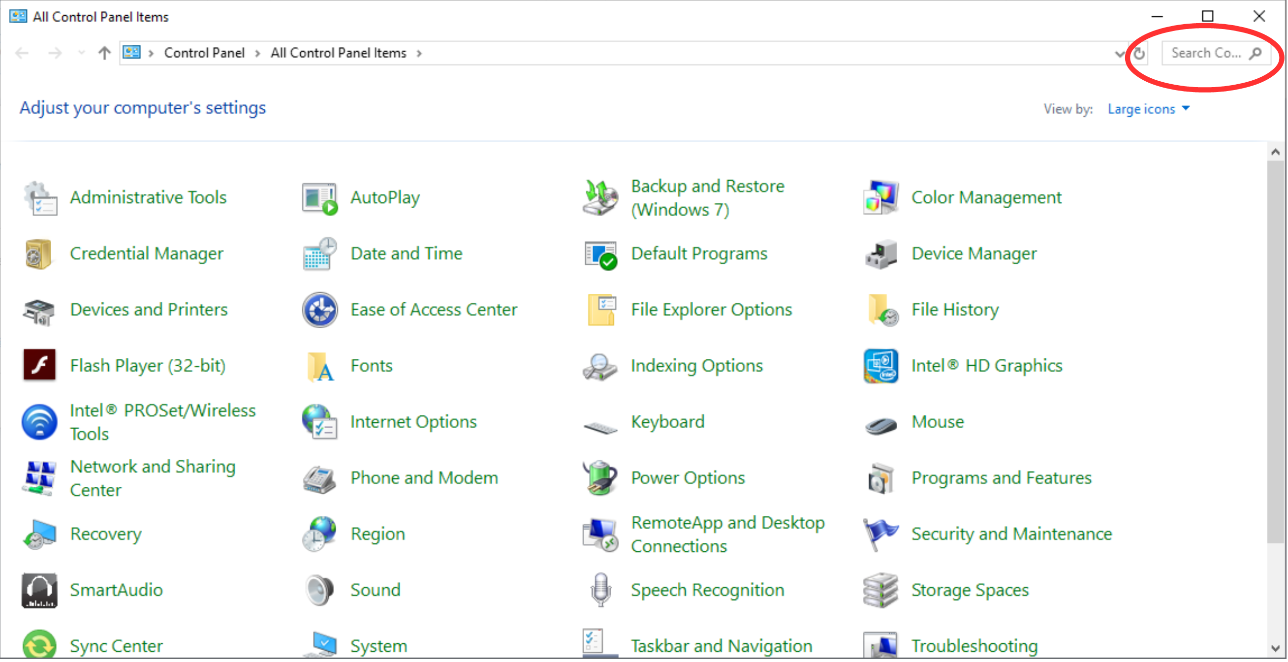
Illustration 1.

Note the Search field in the upper right corner, which is circled in the illustration.
Click in the Search field, so a cursor appears there. Type Screen Saver. Results appear immediately, so you do not need to tap the Enter key.

Control Panel Search is a great quick way to reach specific parts of the Windows 10 settings without learning exactly how to navigate through three or four screens.
In this case, Search shows a results page such as that depicted in Illustration 2.
Under the heading Power Options, click on Change Screen Saver, which is circled in Illustration 2.
The Screen saver dialog window appears, as shown in Illustration 3. This is where you can get down to the business of activating and configuring your Photos screen saver.
The dialog window includes a dropdown menu for the selection of screen saver types. Initially, yours will likely say None, which is the default.

There is a down-arrow symbol to the right of the screen saver type selection; I included a pointer in the illustration to draw your attention to that symbol. Left click on that down-arrow symbol.
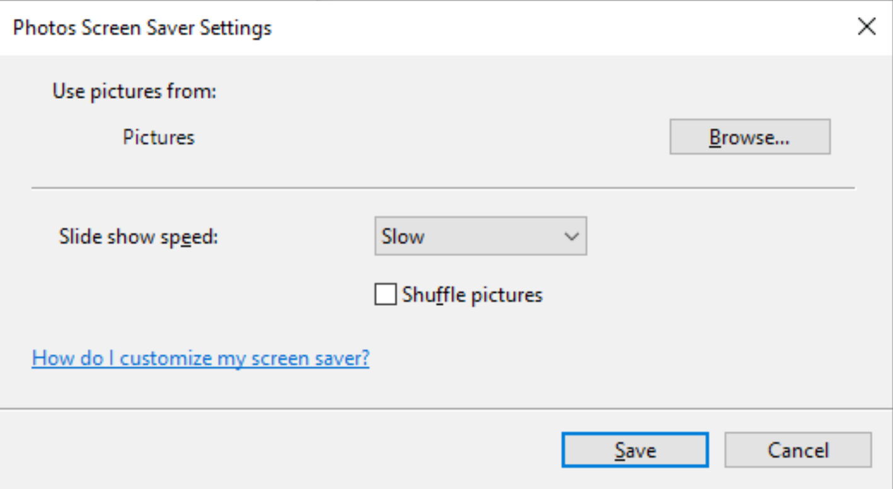
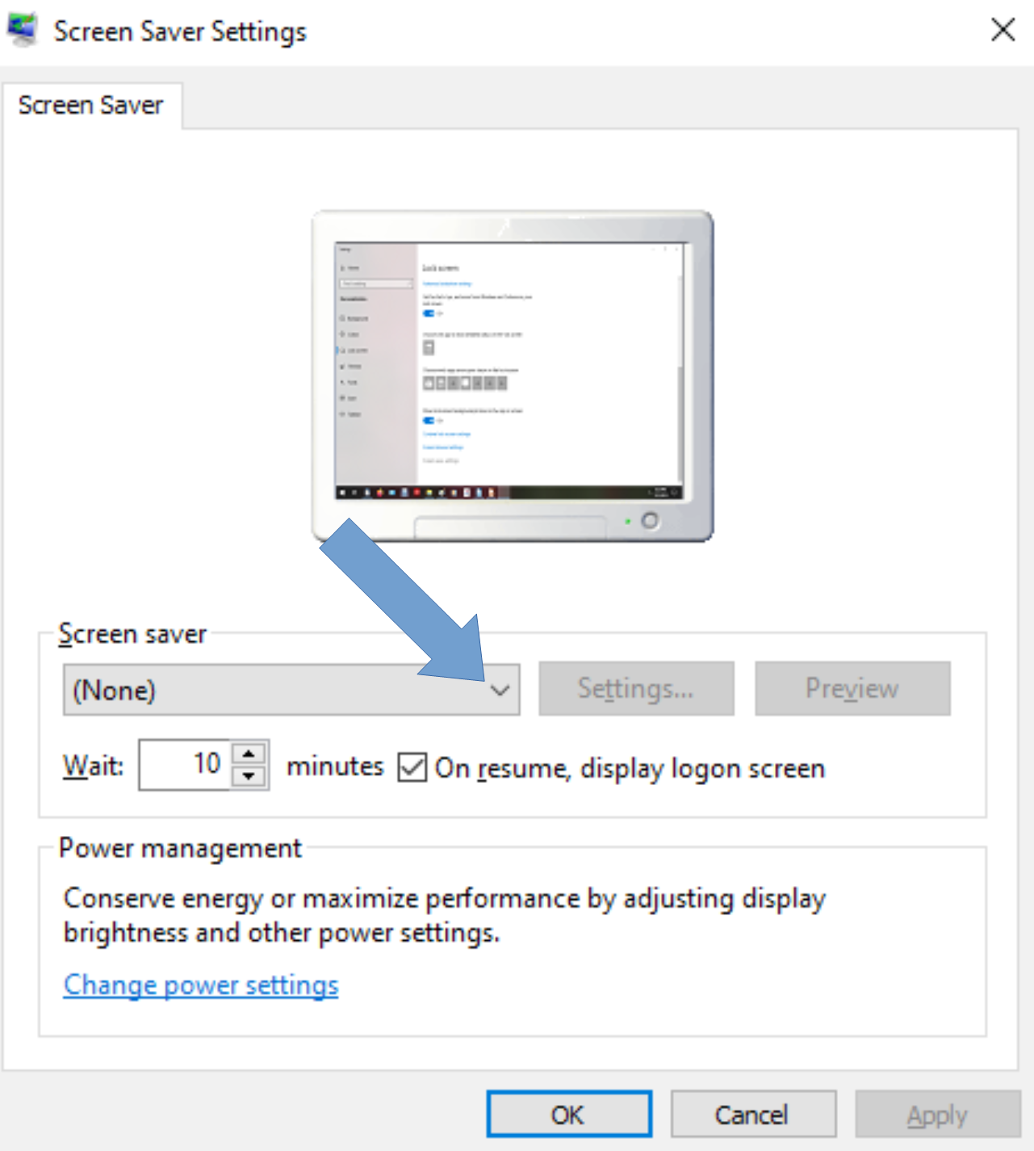

Illustration 4

A typical menu is shown in Illustration 4. Yours may differ depending on when you obtained your version of Windows because some types are added from time to time. Photos, which has been a Windows screen saver for a very long time, should appear in all the versions of the menu and is circled in illustration 4. Select Photos.
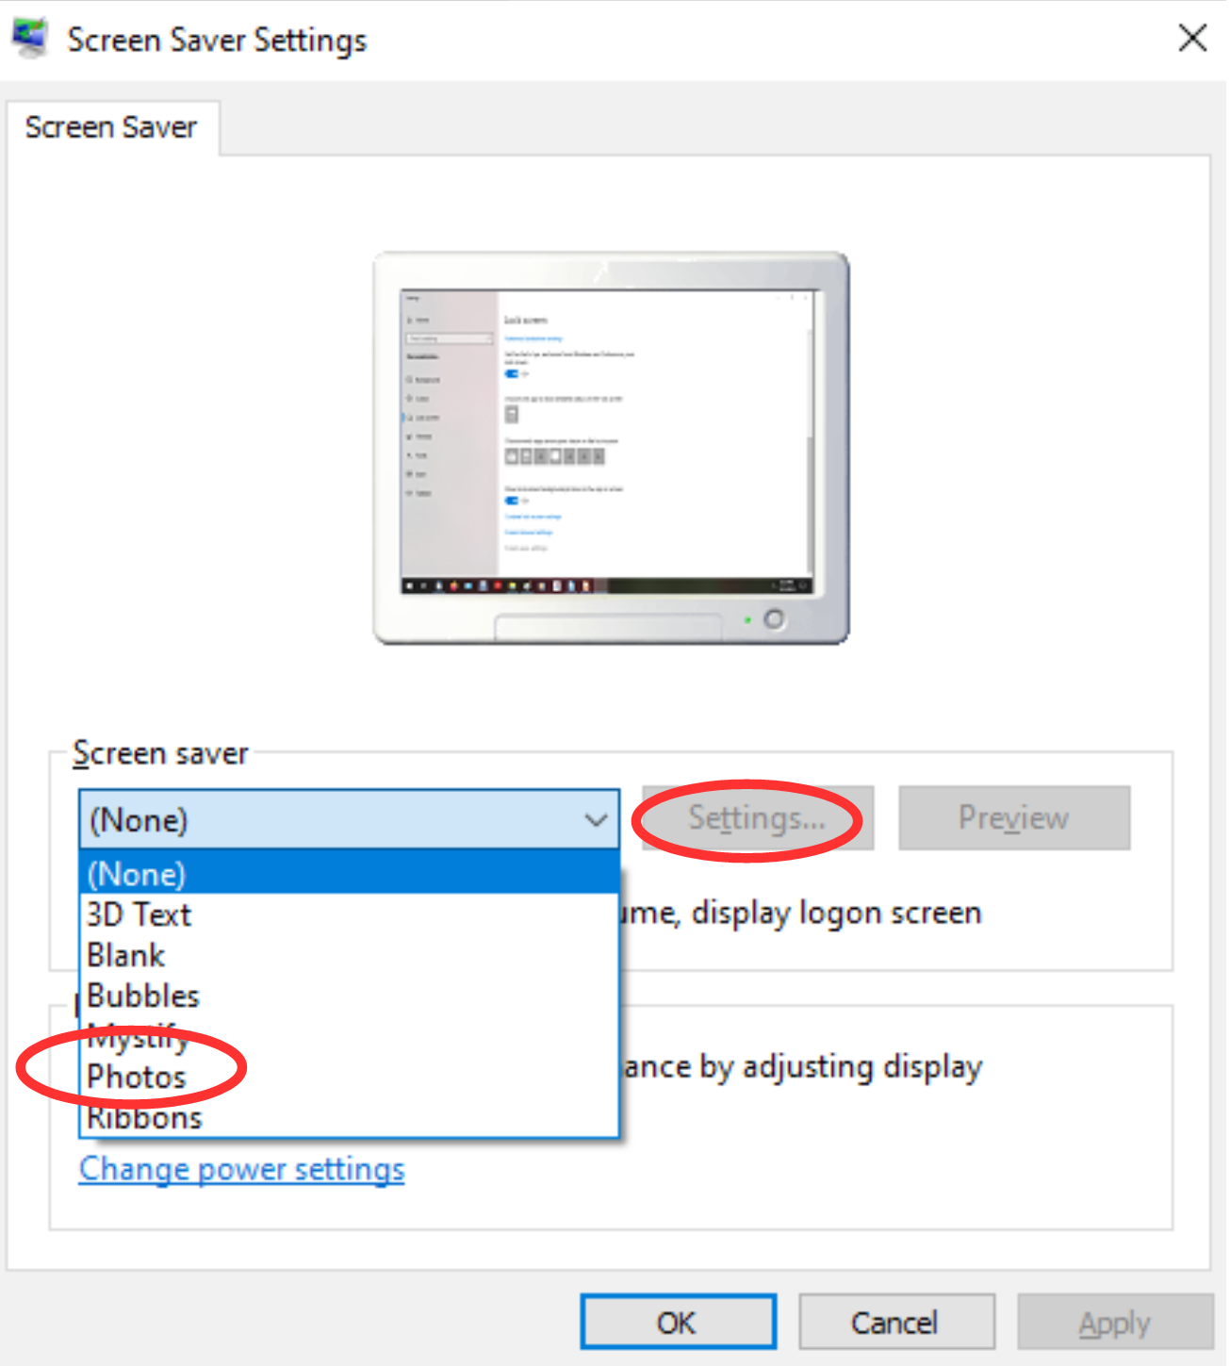
Selection from the menu causes the menu to disappear. You can tell that you selected Photos because that word remains visible, to the left of the down-arrow.

After that, in the dialog window, the Settings button is active. Click on the Settings button, which is also circled in Illustration 4. A Screen Saver Settings dialog window opens. That dialog window is shown in Illustration 5.

Illustration 5

The Settings dialog window has three important purposes.

The first purpose is to specify the folder in which you stored your selected photos in Step One above. The default folder is Pictures. If you put your screen saver photos in Pictures, then you do not need to change this setting. Otherwise, click the Browse button, and a standard Windows folder selection navigator window appears. Navigate to and select your folder, and then click the OK button in the folder selection window.

The second purpose is to choose the speed of the slide show of photos, meaning the duration of each photo on the screen. The speed options include Slow, Medium, and Fast. Not very descriptive, right?

The speed is a matter of individual taste. Try Medium first. In a moment or two, you will learn how to test that setting. If that speed is not ideal for you, then go back to the Screen Saver Settings window, change the speed setting, and test again.

The actual duration of photo display each setting on your computer depends on a great variety of factors, such as the speed of your hard drive, the speed of your CPU, the amount of RAM memory in your computer, and the number of programs running on your computer.

The third purpose is to choose the order in which the photos are displayed. The Shuffle checkbox tells the computer to display the photos in Random Order. If you do not check that box, then the photos will be displayed in filename order.
Once you are done with the settings, click on the Save button, and the Settings window closes.

Third Step: You can test your slide show by clicking the Preview button in the Screen Saver dialog window. This preview capability allows you to see the actual duration of each photo. You can try it out and decide if the speed is too fast or too slow for your taste, and then reopen the Screen Saver Settings window to adjust the speed if necessary.

When you are done setting up your screen saver, tap the OK button at the bottom of the dialog window. The dialog window closes. You can close the Control Panel Search Results screen as well.

After that, all you have to do is wait, keep your hands off your mouse and keyboard. Eventually, your customized screen saver will take over.

ABOUT THE AUTHOR: John Krout is a past president of the Washington Area Computer User Group (WAC). After his tenure, the group merged with another to form the Potomac Area Technology and Computer Society (PATACS). He has been taking photos since the early 1960s and writing about the uses of personal computers since the early 1980s. His digital photos won first and second place in the 2018 Association of PC User Groups (APCUG) digital photo contest. After many years working as a software engineer using C and C++, now John is a tech writer for the Thales Group, supporting the use of that company’s advanced automatic fingerprint matching technology in the computer system of a major federal government agency.

